**Building Docker Image with Spring Boot Maven Plugin**

**Refer** [**https://spring.io/guides/gs/spring-boot-docker**](https://spring.io/guides/gs/spring-boot-docker)

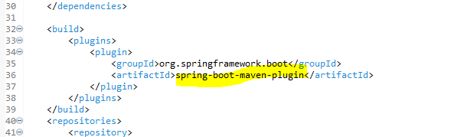

Go to Run->Maven Build->Main-> add Goals as **spring-boot:build-image**

